**PROJECT NAME: COACHING CLASS WEBSITE**

Team Members:

* VAIBHAV SHINDE
* VANSH SINGH
* SUMIT GIRI
* SHUBHANGI AGARWAL

COLOUR PALATTE:

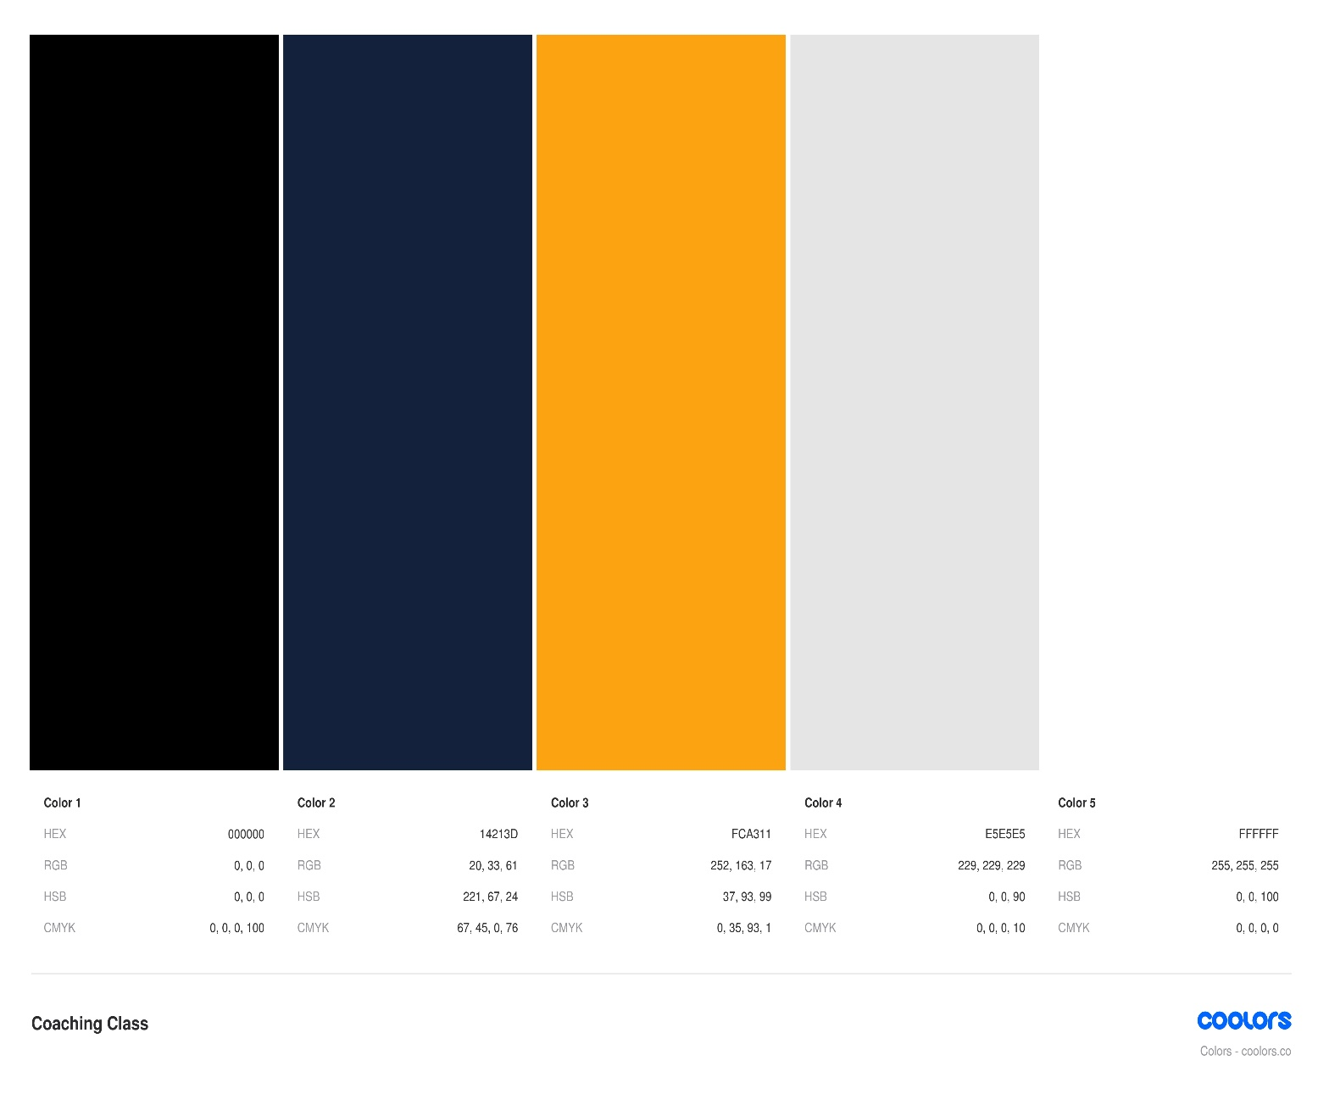

FONTS USED:

* UBUNTU-BOLD
* UBUNTU-BOLDITALIC
* UBUNTU-ITALIC
* UBUNTU-LIGHT
* UBUNTU-LIGHTITALIC
* UBUNTU-MEDIUM
* UBUNTU-MEDIUMITALIC
* UBUNTU-REGULAR

WIREFRAMING:

1. HOME PAGE

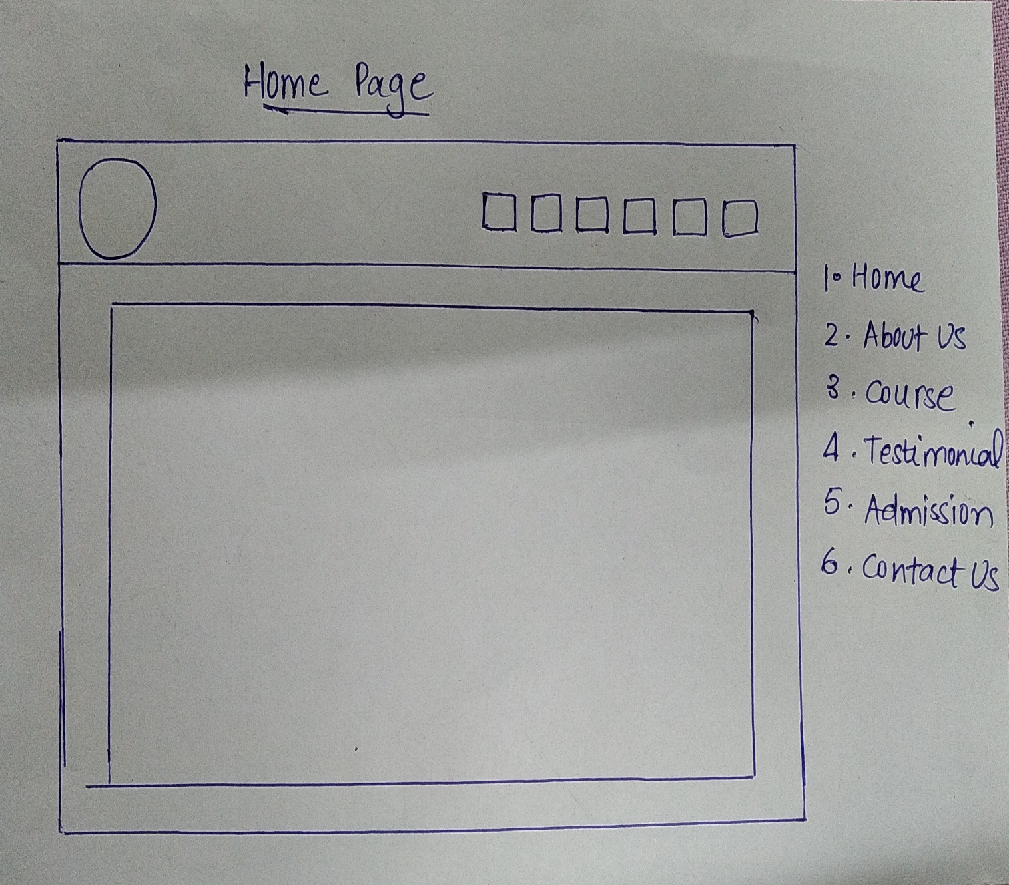

1. ABOUT US PAGE

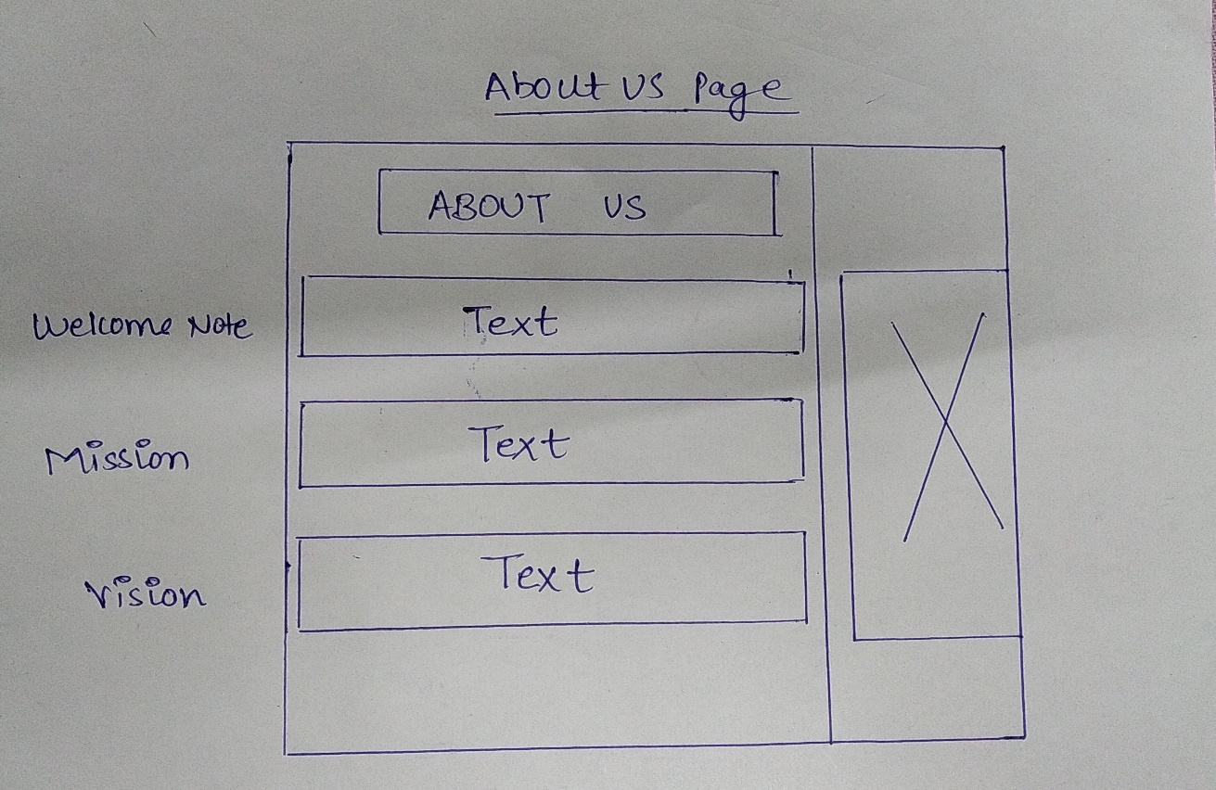

1. COURSES

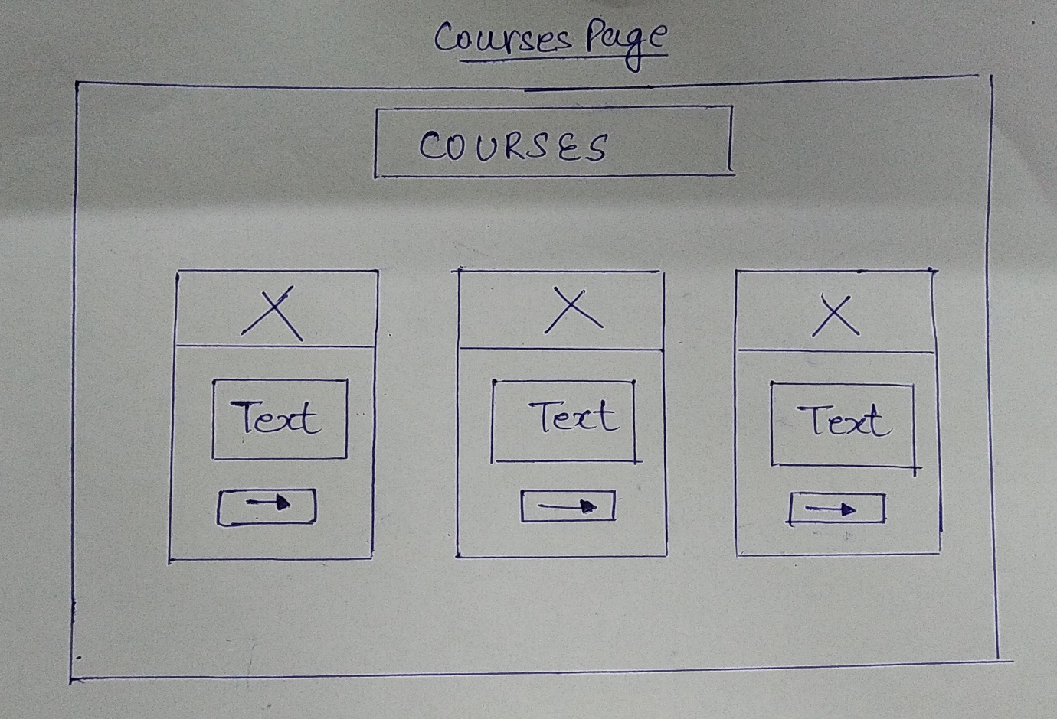

1. TESTIMONIAL

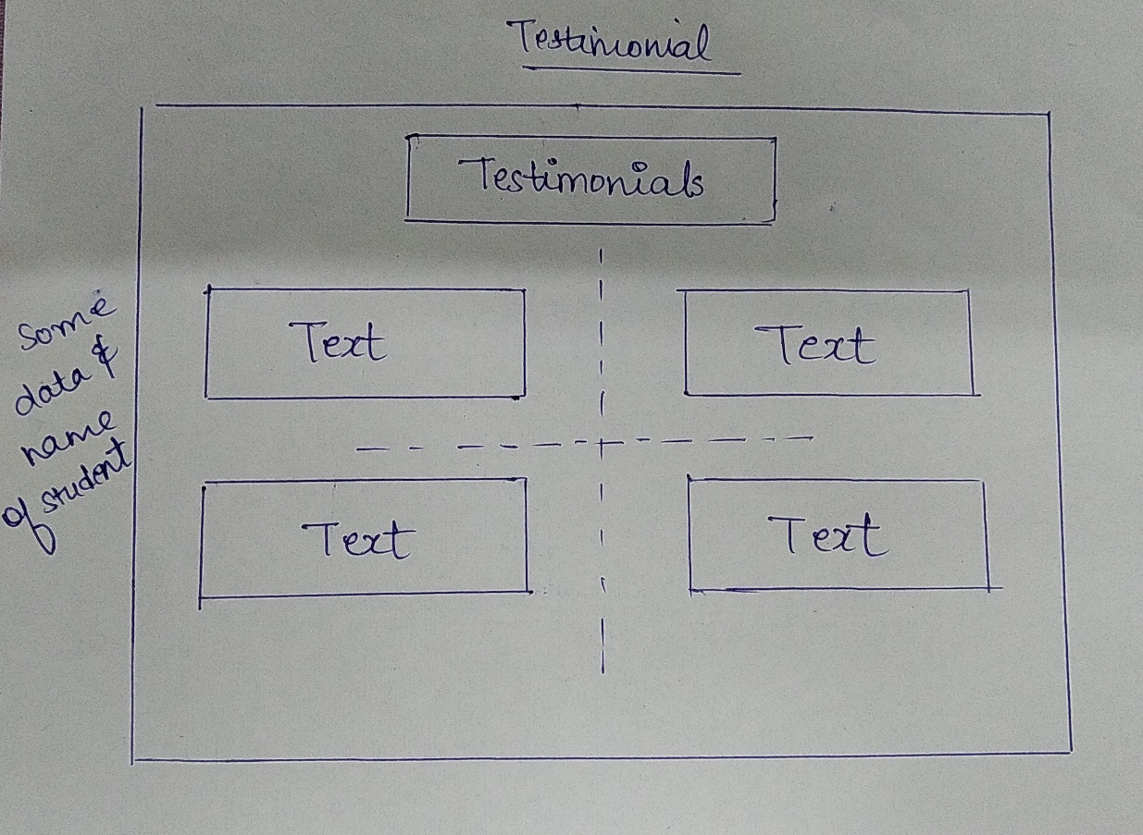

1. ADMISSION PAGE

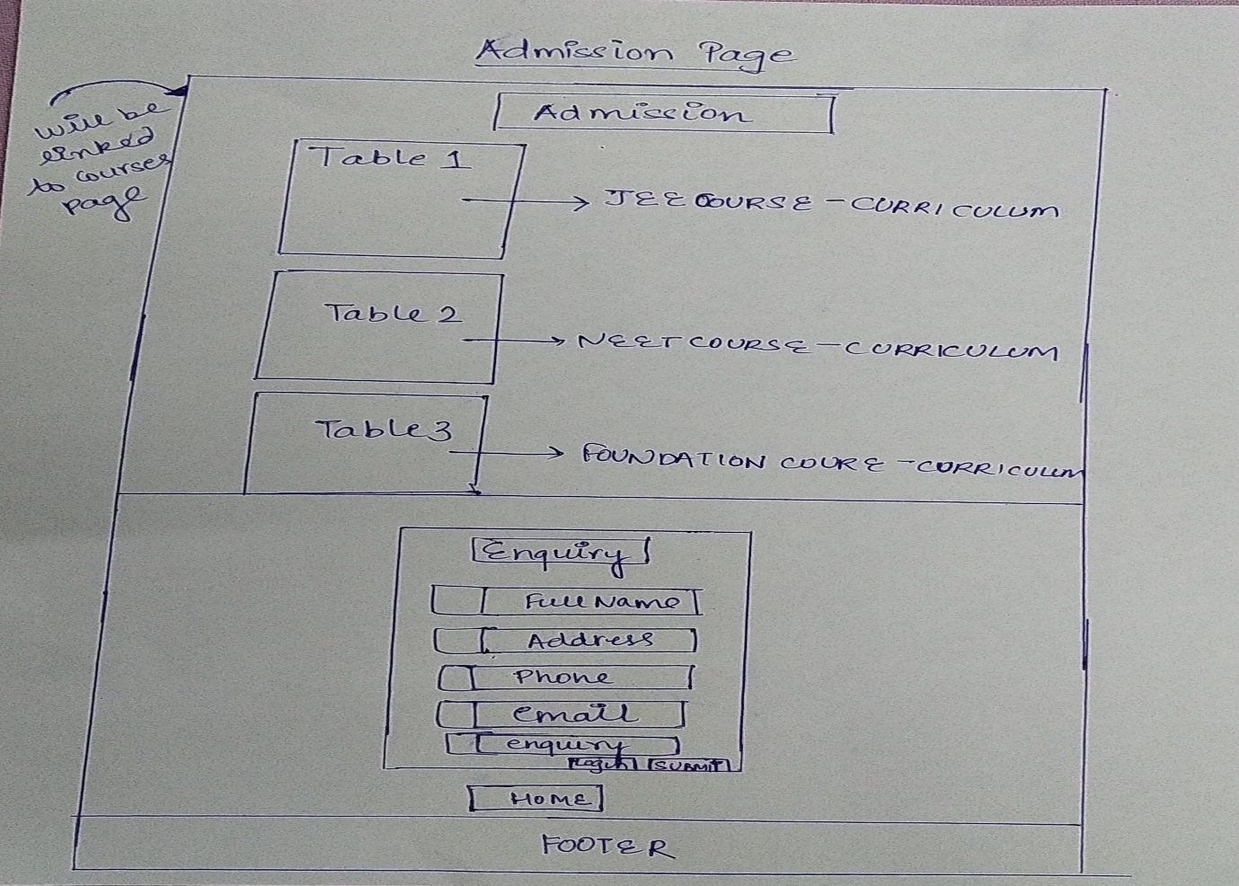

1. CONTACT US

